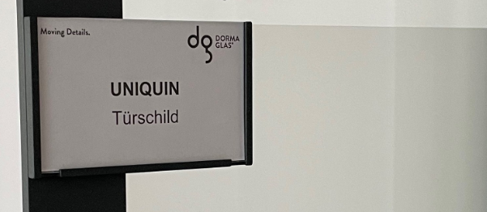

Dear Sir or Madam.

Who hasn't experienced this: a large office floor, room after room, and the search begins. Where is the right department and who sits in which office? Glass partitions with UNIQUIN at least allow first insights. But who can provide quick and precise information?

UNIQUIN door plates.
For better orientation and identification.

The most important information can be easily placed on an area of 80 x 130 mm, e.g. room number, department, name. Or room use, office hours and substitutions. Simply everything that helps colleagues and visitors find their way around. In addition, teams are visible here by name, for better identification with the area of responsibility in the company.

As from one cast.

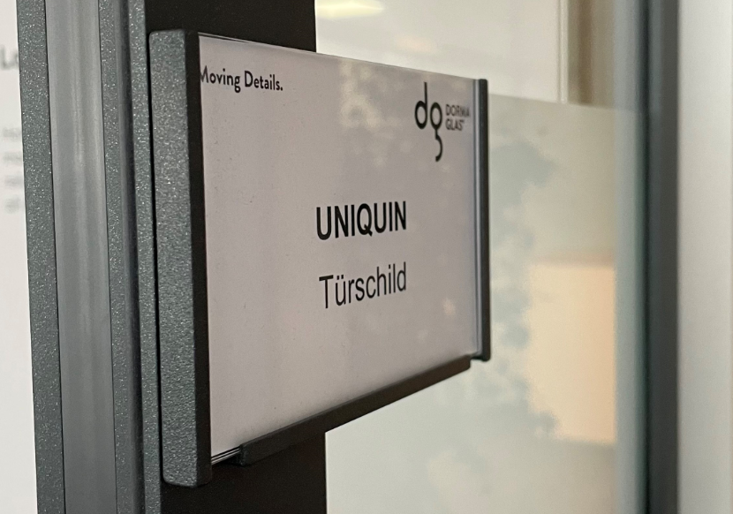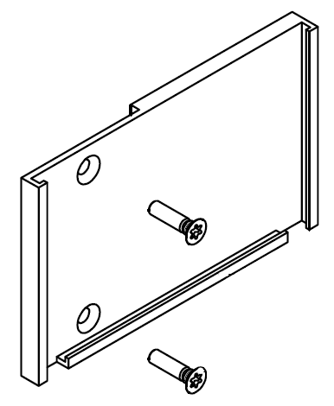

The UNIQUIN door plate (right hand or left hand) is designed to fit perfectly to the UNIQUIN frame profile and continues in the projecting area on the glass. Powder-coated in system color, it appears like a fully integrated element at the door.

The installation is very simple: The door plate is fixed to the previously drilled frame profile with two countersunk screws. The preparation (2 drill holes) and the complete mounting of the door plate can also be carried out subsequently on already installed systems. Lettering is simply inserted from above into the 4 mm deep surround. The user has a free hand in the choice of material and the production of the inscriptions. Replacement is possible at any time.

Detailed information can be found in the attachment: Mounting instructions and drawings on the detail sheet.

Do you have any questions?

Simply get in touch with your contact person in our regionally oriented internal sales service. We look forward to being able to help you.

Signatur

With best regards

DORMA-Glas GmbH

